ABSTRACT
Online reviews play a crucial role in shaping consumer purchasing decisions and offer companies insightful feedback on their products and services. Given the profound influence of these reviews, there is a rising concern over the creation of fake reviews intended to manipulate public perception, either by artificially inflating a product’s reputation or by unfairly tarnishing a competitor’s image. This deceptive practice, known as Opinion (Review) Spam, is driven by individuals or entities seeking financial gain through the dissemination of false or misleading reviews. The manual identification of such fake reviews is not only labor-intensive but also impractical due to the sheer volume of online content. Therefore, automated detection methods are imperative for ensuring the integrity of online reviews
To address this challenge, our study leverages Natural Language Processing (NLP) and advanced machine learning techniques to analyze and classify review texts. By extracting significant linguistic features, these technologies help in discerning genuine reviews from fraudulent ones. Fake reviewers often employ specific word patterns and stylistic choices intended to influence readers, creating a distinct linguistic signature. By detecting these patterns, our approach can effectively identify deceptive reviews.
We have implemented several preprocessing steps including stop word removal, stemming, tokenization, and part-of-speech (POS) tagging to prepare the data for analysis. Additionally, we applied sentiment analysis to understand the emotional tone of the reviews, which further aids in the detection process. Our methodology incorporates a hybrid decision-making framework that combines machine learning models like Convolutional Neural Networks (CNN) and Random Forests with fuzzification techniques and user-defined rules. This hybrid approach enhances the system's adaptability and accuracy in detecting fake reviews.
Through this comprehensive and automated method, our research aims to improve the efficiency and effectiveness of fake review detection, ensuring that consumers receive reliable information and companies can maintain their reputations based on genuine customer feedback.

Introduction

In today's digital landscape, online reviews wield substantial influence over consumer decision-making processes, serving as a cornerstone for evaluating products and services. However, amidst the wealth of genuine feedback lies the pervasive issue of fake reviews, a phenomenon known as Opinion (Review) Spam. These deceptive reviews, deliberately engineered to manipulate consumer perceptions, pose a significant challenge to the integrity of online review systems.

To combat this challenge, a multifaceted approach combining advanced computational techniques and machine learning algorithms has emerged. Leveraging the power of Natural Language Processing (NLP) and machine learning, researchers and practitioners have devised innovative methodologies to detect and mitigate the impact of fake reviews.

In the pursuit of developing effective fake review detection systems, a myriad of techniques have been employed. This includes data preprocessing steps such as filtration, stop-word removal, stemming, tokenization, and Part-of-Speech (POS) tagging, which lay the groundwork for extracting meaningful insights from textual data. Furthermore, sentiment analysis techniques have been harnessed to discern the emotional tone of reviews, providing valuable cues for identifying deceptive content.

Beyond basic preprocessing and sentiment analysis, more sophisticated approaches have been explored. These encompass the integration of user-defined rules, enabling the incorporation of domain-specific knowledge and criteria into the detection process. Additionally, machine learning models, ranging from traditional classifiers like Random Forest to deep learning architectures such as Convolutional Neural Networks (CNN), have been deployed to discern patterns indicative of fake reviews.

In the quest for enhanced accuracy and robustness, hybridization techniques have emerged as a promising avenue. By fusing multiple methodologies, such as machine learning and rule-based systems, hybrid approaches offer a synergistic solution that leverages the strengths of individual techniques while mitigating their limitations. Moreover, fuzzification techniques have been employed to introduce flexibility and adaptability into the decision-making process, accommodating uncertainty and imprecision inherent in real-world data.

This introduction sets the stage for a comprehensive exploration of fake review detection methodologies, encompassing both traditional approaches and cutting-edge innovations. Through an in-depth analysis of the techniques employed, we aim to elucidate the challenges and opportunities inherent in combatting fake reviews in the digital age.
PROBLEM STATEMENT

As the use of online products and application has been increasing at a rapid rate, the competition in the market is increasing day by day. Business officials in order to fame their products and defame other competitor products may get people from other marketplace or hire them to post and give fake judgements on the products .So to safeguard the authenticity of the online products and opinions various steps and methods are needed to be applied.

Financially if we look at the situation, the opinions and reviews on various products may cost a lot to one company if people are actually relying on those reviews. If the reviews are original and authentic then the results are more obvious and fair, But if we ponder over the other side then the situation reverses. More and more fake reviews will cause a huge loss for the company which has got good and better products to sale which causes a huge financial loss to the growing company.

Fake Review Detection will help us to identify whether the opinion given to the product is a true or fake review. Various methods can be used to detect it but we our focusing on finding the results using Machine learning Techniques.

Our method focuses on the text content of the costumer reviews. People who tend to write fake reviews choose topics or words to influence online customers thus their word choice is different than others. This word choice pattern can be used for segregation of fake and truthful reviews. If these reviews are detected properly, then fake reviews may be automatically removed after detection, which may help to generate only the genuine information and serve as a boon to the companies and market especially the customers.

Methodology

The methodology employed in the proposed fake review detection system adopts a hybrid approach, amalgamating machine learning principles with rule-based techniques. This multifaceted strategy encompasses several modules meticulously designed to aggregate, preprocess, scrutinize, and categorize textual reviews, thereby amplifying the precision and dependability of the detection process.

Module 1: Data Collection

This module is dedicated to sourcing review data from diverse channels, including prominent online review platforms like Amazon, Yelp, and TripAdvisor, as well as e-commerce websites such as eBay and Walmart. The data collection strategy entails leveraging APIs provided by these platforms for structured data retrieval, alongside web scraping techniques utilizing libraries like BeautifulSoup or Scrapy for unstructured data extraction.

Module 2: Data Pre-processing

Within this module, the raw review data undergoes a series of preprocessing steps to refine, standardize, and organize it into a structured format conducive to subsequent analysis. Tasks encompassed in this phase include text cleansing to eliminate special characters and HTML tags, tokenization for segmenting text into meaningful units, lowercasing, removal of stopwords, stemming or lemmatization to normalize word forms, and encoding of categorical variables. Additionally, missing data are handled using imputation techniques, numerical features are normalized, and measures are implemented to ensure data integrity and quality.

Module 3: Sentiment Analysis

This module is focused on discerning the sentiment conveyed within the preprocessed reviews to glean insights into their emotional tenor and authenticity. Various sentiment analysis techniques, ranging from lexicon-based methods to machine learning algorithms, are leveraged to assign sentiment scores (positive, negative, neutral) to each review. These sentiment scores serve as pivotal features in subsequent classification tasks, enriching the dataset and bolstering the detection model's ability to discriminate between genuine and deceptive reviews based on nuanced sentiment patterns.

Polarity= Total number of words ∑word∈positive​score (word)−∑word ∈ negative ​score (word)​
Total number of words

User-defined Rules:
Custom Rules defined by system administrators based on domain-specific knowledge to enhance decision-making flexibility. For instance, setting thresholds for certain features that indicate review authenticity.

Review Classification
The review classification module of the proposed system employs a hybrid approach, combining various machine learning techniques to accurately identify fake reviews. This module integrates preprocessing steps, feature extraction, and classification algorithms to achieve high performance.

CNN Classification
The Convolutional Neural Network (CNN) classification involves several steps, each utilizing specific formulas to process the input data, extract features, and ultimately classify the reviews. Below are the key components and formulas involved in CNN classification:

Input Layer
Embedding Layer: Converts words into dense vectors of fixed size.
Embedding (𝑥) =𝑊𝑒⋅𝑥Embedding(x) =We​⋅x
where 𝑥x is the one-hot encoded input vector and 𝑊𝑒We​ is the embedding matrix.

Convolutional Layer
Convolution Operation: Applies convolutional filters to the input data.
ℎ𝑖=𝜎(𝑊𝑐⋅𝑥𝑖:𝑖+𝑘−1+𝑏𝑐)hi​=σ(Wc​⋅xi:i+k−1​+bc​)
where:
𝑊𝑐Wc​ is the filter matrix
𝑥𝑖:𝑖+𝑘−1xi:i+k−1​ is the input window of size 𝑘k
𝑏𝑐bc​ is the bias term
𝜎σ is the activation function (e.g., ReLU)

Activation Function
ReLU Activation: Applies the Rectified Linear Unit function to introduce non-linearity.
ReLU(𝑧)=max⁡(0,𝑧)ReLU(z)=max(0,z)
Pooling Layer
Max Pooling: Reduces dimensionality by selecting the maximum value in each window.
ℎ𝑖(𝑝)=max⁡(ℎ𝑖:𝑖+𝑝−1)hi(p)​=max(hi:i+p−1​)
where 𝑝p is the pooling window size.
Fully Connected Layer
Dense Layer: Connects all neurons from the previous layer to each neuron in this layer.
ℎ=𝜎(𝑊𝑓⋅ℎpool+𝑏𝑓)h=σ(Wf​⋅hpool​+bf​)
where:
𝑊𝑓Wf​ is the weight matrix

ℎpool hpool​ is the pooled feature vector
𝑏𝑓 bf​ is the bias term

Output Layer
Softmax Activation: Converts the output logits into probabilities.

Softmax(𝑧𝑖)= 𝑒𝑧𝑖
∑𝑗𝑒𝑧𝑗Softmax(zi​)=∑j​ezj​ezi​​

where 𝑧𝑖zi​ are the logits for each class.

Loss Function
Cross-Entropy Loss:
Measures the difference between the predicted probabilities and the actual class labels.

N C
𝐿= -1 ∑ ​ ∑ ​yi,c ​log(y^​i,c​)
N ​i=1 c=1

where:
𝑁N is the number of samples
𝐶C is the number of classes
𝑦𝑖,𝑐yi,c​ is the actual label (1 if sample 𝑖i belongs to class 𝑐c, 0 otherwise)
𝑦^𝑖,𝑐y^​i,c​ is the predicted probability for class 𝑐c
8. Backpropagation and Optimization

Random Forest
Random Forest is an ensemble learning method that operates by constructing multiple decision trees during training and outputting the mode of the classes (classification) or mean prediction (regression) of the individual trees.
N
y = 1 ∑ yi
N i=1
where 𝑦^𝑖y^​i​ is the prediction from the 𝑖i-th tree and 𝑁N is the total number of trees.

Fuzzification
Fuzzification is the process of converting crisp input values into degrees of membership for fuzzy sets. This process is integral to fuzzy logic systems and allows handling uncertainty and imprecision in data.

0 if x ≤ a
μA​(x)= x-a/b-a if a < x ≤ b
c-x/c-b if b < x < c
0 if x > c

Module 4: Hybrid Decision Making
The Hybrid Decision-Making module epitomizes the fusion of machine learning prowess with fuzzy logic and user-defined rules to orchestrate a robust and adaptive decision-making framework. Machine learning models are deployed to make informed predictions and classifications, drawing upon discernible patterns within the data. Fuzzification techniques inject flexibility into the decision-making process, adeptly navigating uncertainty and imprecision, while user-defined rules empower system administrators to tailor decision criteria, accommodating domain-specific insights and refining the decision process. This amalgamated approach ensures a dynamic and effective decision-making mechanism capable of addressing diverse scenarios while affording users the latitude to customize system behavior to suit their unique needs.

Module 5: Prediction and Visualization

In this module, the trained model is enlisted to prognosticate the authenticity of reviews, and the outcomes are visualized to facilitate comprehension and interpretation. Visual representations, employing tools are coupled with performance metrics, enhance understanding of the model's efficacy in discerning fake reviews. These visual aids play a pivotal role in decision-making processes and furnish insights into the system's reliability and accuracy.

When evaluating the machine learning model's performance, an array of metrics such as accuracy, precision, recall (sensitivity), F1-score are employed, tailored to the specific objectives and nature of the problem at hand. These metrics collectively furnish a comprehensive appraisal of the model's efficacy and proficiency in identifying fake reviews.

Literature Review

The landscape of fake review detection has garnered significant attention in scholarly research, reflecting the escalating concern over the integrity of online reviews and their influence on consumer decision-making. A thorough examination of existing literature unveils diverse methodologies, ranging from traditional linguistic analyses to advanced machine learning techniques, aimed at mitigating the proliferation of deceptive reviews.

Sami Ben Jabeur et al. (2023), in their study, underscore the prevalence of fake online product reviews and the consequential impact on consumer trust and market fairness. Embracing insights from psychology and computational linguistics, the research advocates for the integration of artificial intelligence (AI) and machine learning (ML) in enhancing detection accuracy. However, the study acknowledges the inherent challenge of subjectivity in classification, necessitating a nuanced approach to strike a balance between false positives and false negatives.

Kamel et al. (2022) delve into the realm of fake review detection employing advanced language models such as ULMFiT and GPT-2. Their findings accentuate the formidable capability of machine classifiers in identifying fake reviews, outperforming human raters in accuracy. Nonetheless, the study cautions against the risk of false positives, underscoring the imperative of refining detection algorithms to minimize erroneous classifications.

R. Mohaeesh and Shuxiang Xu (2021) provide a comprehensive survey of techniques and tools employed in detecting fraudulent reviews across online platforms. Delving into machine learning, natural language processing, and deep learning methodologies, the authors offer valuable insights into the evolving landscape of fake review detection. However, the survey's limitation lies in its potential omission of recent advancements and emerging challenges, given the dynamic nature of the field.

Alexander Nikolaev (2021) presents a comprehensive overview of existing research endeavors in detecting fake reviews in the domain of online e-commerce. While elucidating various techniques and approaches, the study sheds light on the advancements made to ensure more reliable and trustworthy online shopping experiences. However, the review's focus on extant research may preclude coverage of the latest developments, necessitating ongoing exploration to address evolving challenges.

Kim and Lee (2021) propose an innovative approach to detect deep fake content by leveraging textual and audio-visual information. Their methodological fusion aims to bolster accuracy and robustness in detecting deceptive multimedia content, aligning with broader endeavors to combat misinformation in the digital era.

Li et al. (2021) put forth a novel approach, DETEC, for identifying group-collusive fake reviews on online platforms. Employing iterative model refinement techniques, the research seeks to enhance accuracy in detecting coordinated efforts to manipulate product reviews. The study's focus on addressing group-collusive fake reviews underscores the multifaceted nature of deceptive practices in online environments.

J. Suh and J. Kim (2021) propose a fake review detection methodology utilizing sentiment analysis and machine learning techniques. Their approach underscores the pivotal role of sentiment analysis in discerning deceptive reviews, complemented by machine learning algorithms to enhance detection accuracy.

Y. Zhou et al. (2021) delve into fake review detection via heterogeneous graph-based learning with hierarchical attention mechanisms. Their innovative approach harnesses graph-based learning to discern patterns indicative of fraudulent reviews, reflecting the ongoing quest for novel methodologies in combating deceptive practices.

Nguyen et al. (2021) advocate for a hybrid framework integrating deep learning and traditional machine learning techniques for fake review detection. Their methodology amalgamates the strengths of both paradigms, aiming to optimize detection accuracy and resilience to evolving deceptive tactics.

Ashok Kumar et al. (2019), in their proceedings, provide insights into the proceedings of the International Conference on Artificial Intelligence, Smart Grid, and Smart City Applications. While not specifically focused on fake review detection, the conference proceedings likely encapsulate broader discussions surrounding AI applications and their implications across diverse domains.

Collectively, these studies illuminate the multifaceted nature of fake review detection, encompassing a spectrum of methodologies ranging from linguistic analyses to advanced machine learning algorithms. Despite notable advancements, ongoing research is essential to address emerging challenges and fortify the resilience of detection systems against evolving deceptive tactics in online environments.

SYSTEM DEVELOPMENT

DATASET
The foundation of any data-driven system lies in the quality and relevance of the dataset utilized for training and evaluation. In the context of fake review detection, the dataset serves as the bedrock upon which algorithms are trained to discern patterns indicative of deceptive or genuine reviews. A judiciously curated dataset not only facilitates the development and validation of detection models but also lays the groundwork for benchmarking and comparative analysis.
The dataset selection process hinges on several key factors, including the diversity of review sources, the volume of data, and the veracity of labels. Embracing a diverse array of online review platforms, ranging from e-commerce giants like Amazon and eBay to niche industry-specific forums, enriches the dataset with varied linguistic styles, product categories, and user demographics. Moreover, prioritizing datasets with meticulously annotated labels, distinguishing between genuine and fake reviews, ensures the integrity and reliability of training and evaluation procedures.
Ethical considerations underscore every stage of the dataset development process, ensuring the responsible handling of user-generated content and safeguarding user privacy. Respect for platform-specific terms of service and data usage policies is paramount, guiding the ethical collection and utilization of online review data. Moreover, stringent measures are implemented to anonymize and de-identify user-generated content, preserving user anonymity and confidentiality while upholding data protection principles.

Category | Reviews | Truthful reviews | Fake  Reviews
Computer and accessories | 600 | 300 | 300
Electronics | 200 | 110 | 90
Musical instruments | 100 | 50 | 50
Home and kitchen | 500 | 250 | 250
Office Products | 500 | 250 | 250
Toys and games | 300 | 150 | 150

System model:
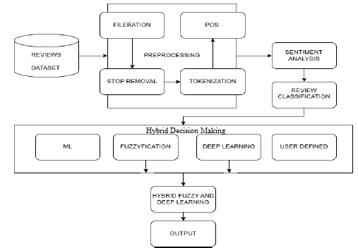

Algorithms
Filtration:
Filtration, in the context of text processing, refers to the process of removing irrelevant or unwanted information from the text data. This can include removing special characters, punctuation, HTML tags, or any other noise that may interfere with the analysis or interpretation of the text. Filtration is often performed as a preprocessing step before more advanced text analysis techniques are applied.
The purpose of filtration is to clean the text data and prepare it for further processing, such as tokenization, part-of-speech tagging, or sentiment analysis. By removing noise and irrelevant information, filtration helps to improve the quality of the text data and ensures that subsequent analysis steps are based on meaningful content. Additionally, filtration can help standardize the format of text data, making it easier to work with and analyze using automated algorithms.

Stop Word Removal:
Stop words are common words that frequently occur in text but typically do not carry significant meaning or contribute to the understanding of the text. Examples of stop words include "the", "and", "is", "in", etc. In natural language processing (NLP), stop word removal is a preprocessing step aimed at filtering out these common words from text data before further analysis. The goal of stop word removal is to reduce the dimensionality of the data and focus on the words that are more informative for the task at hand.
Stop word removal involves creating a list of stop words specific to the language being analyzed and then removing occurrences of these words from the text. This process can be implemented using various techniques, including simple list-based removal, regular expressions, or specialized NLP libraries. After stop word removal, the remaining words in the text are typically more relevant to the underlying semantics and can better represent the content for subsequent analysis tasks such as sentiment analysis or text classification.

Stemming:
Stemming is a linguistic normalization technique used to reduce words to their base or root form, known as the stem. The purpose of stemming is to group together words that have the same root, even if they are inflected or derived forms of the same word. For example, "running", "runs", and "ran" would all be reduced to the stem "run". Stemming helps to simplify text data by treating similar words as equivalent, which can improve the performance of text processing and analysis algorithms.
There are different algorithms for stemming, with Porter stemming and Snowball stemming being among the most commonly used ones. These algorithms apply a series of rules to strip affixes (prefixes and suffixes) from words, resulting in their base form. Stemming is particularly useful in tasks such as information retrieval, where matching documents based on their semantic content is more important than exact word matches.

Sentiment Analysis:
Sentiment analysis, also known as opinion mining, is a natural language processing (NLP) task aimed at determining the sentiment or emotional tone expressed in text data. The goal of sentiment analysis is to classify text documents or sentences as expressing positive, negative, or neutral sentiments based on the underlying emotions conveyed by the words.
Sentiment analysis can be performed using various techniques, including lexicon-based methods, machine learning algorithms, and deep learning models. Lexicon-based methods rely on sentiment lexicons or dictionaries containing words annotated with their sentiment polarity (e.g., positive or negative). These methods assign sentiment scores to text based on the presence of words with known sentiment polarity.
Machine learning approaches to sentiment analysis involve training classifiers on labeled datasets, where each document is assigned a sentiment label (e.g., positive or negative). These classifiers learn patterns in the text data and use them to predict the sentiment of unseen documents. Common machine learning algorithms used for sentiment analysis include support vector machines (SVM), logistic regression, and random forests.
Deep learning models, such as recurrent neural networks (RNNs) and convolutional neural networks (CNNs), have also shown promising results in sentiment analysis tasks. These models can learn complex patterns and representations of text data, capturing contextual information and dependencies between words for more accurate sentiment classification.

Review classification
Review classification using machine learning involves training algorithms to automatically classify reviews into different categories, such as genuine or fake, based on features extracted from the text. This process is crucial for detecting opinion spam and ensuring the authenticity of online reviews, which greatly influence consumer decisions. In this approach, various machine learning algorithms, including Logistic Regression, Naive Bayes, and Support Vector Machines (SVM), are commonly used for classification tasks.

One of the key steps in review classification is feature extraction, where relevant information is extracted from the text data to represent it in a format suitable for machine learning algorithms. Features can include word frequency, n-grams, sentiment scores, and syntactic structures. These features serve as inputs to the classification model, allowing it to learn patterns and make predictions based on the input data.

Logistic Regression is a widely used algorithm for binary classification tasks, such as distinguishing between genuine and fake reviews. It models the probability that a given input belongs to a particular class using the logistic function, which maps input features to a probability score between 0 and 1. The decision boundary separates the input space into regions corresponding to different classes.

Naive Bayes is another popular algorithm for text classification tasks. It is based on Bayes' theorem and assumes that features are conditionally independent given the class label. Despite its simplistic assumption, Naive Bayes often performs well on text classification tasks and is computationally efficient.

Support Vector Machines (SVM) are powerful algorithms for both binary and multiclass classification tasks. SVM aims to find the hyperplane that best separates the data points into different classes while maximizing the margin between classes. It can handle high-dimensional feature spaces and is effective in capturing complex decision boundaries.

The training process involves feeding labeled data (i.e., reviews with known classifications) into the machine learning model, which learns to classify reviews based on the input features. During training, the model adjusts its parameters to minimize a predefined loss function, optimizing its performance on the training data.

Once trained, the model can be used to classify new, unseen reviews by extracting features from the text and feeding them into the trained model. The model then outputs a predicted class label for each review, indicating whether it is genuine or fake.

Evaluation of the classification model is essential to assess its performance and generalization ability. Common evaluation metrics include accuracy, precision, recall, F1-score, and ROC-AUC. These metrics measure different aspects of the model's performance, such as its ability to correctly classify reviews and its robustness to class imbalances.
Formula : The formula for SVM classification involves finding the hyperplane that best separates the data points into different classes. It can be represented as:
𝑦= sign(𝑤⋅𝑥+𝑏) y = sign(w⋅x+b) where 𝑤w represents the weights, 𝑥x denotes the input features, and 𝑏b is the bias term.

CNN (Convolutional Neural Network) classification

CNN (Convolutional Neural Network) classification is a deep learning approach used for tasks such as image classification, natural language processing, and, more recently, text classification, including review classification. CNNs are particularly effective for tasks involving structured input data, such as images or sequences of text.

In CNN classification for text, the network architecture typically consists of multiple layers, including convolutional layers, pooling layers, and fully connected layers. Here's a brief overview of how CNN classification works:

1. Input Layer: The input to the CNN is a sequence of words or tokens representing a review. Each word or token is typically encoded as a vector using techniques like word embeddings (e.g., Word2Vec, GloVe) or one-hot encoding.

2. Convolutional Layers: Convolutional layers apply a set of learnable filters (kernels) to the input text. These filters slide over the input sequence and perform element-wise multiplication with local regions, capturing patterns and features. The output of this operation is called a feature map.

3. Pooling Layers: Pooling layers downsample the feature maps obtained from the convolutional layers, reducing their dimensionality while retaining important features. Max pooling, for example, selects the maximum value from each local region of the feature map, effectively preserving the most important features.

4. Fully Connected Layers: After several convolutional and pooling layers, the high-level features extracted from the input text are flattened and passed through one or more fully connected layers. These layers learn to combine the extracted features and produce the final output logits.

5. Output Layer: The output layer of the CNN classification model typically consists of one or more neurons, each representing a class label (e.g., genuine or fake). A softmax activation function is often applied to the output layer to convert the logits into probabilities, indicating the likelihood of each class.

During training, the parameters of the CNN model (i.e., weights and biases) are optimized using back propagation and gradient descent algorithms to minimize a predefined loss function, such as categorical cross-entropy. The model is trained on a labeled dataset of reviews, where each review is associated with a ground truth class label.

Once trained, the CNN model can be used to classify new, unseen reviews by feeding the input text through the network and obtaining the predicted class probabilities from the output layer. The class with the highest probability is then assigned as the predicted class label for the input review.

CNN classification has been shown to achieve state-of-the-art performance in various text classification tasks, including review classification, due to its ability to automatically learn hierarchical feature representations from the input data. By leveraging the hierarchical structure of text data, CNNs can capture local patterns as well as higher-level semantic features, enabling effective classification of reviews into different categories.

Formula: The formula for a convolutional layer operation involves applying filters to input data, followed by an activation function. Mathematically, it can be represented as: Convolution=ReLU(𝑊∗𝑋+𝑏)Convolution=ReLU(W∗X+b) where 𝑊W represents the filter weights, 𝑋X denotes the input data, 𝑏b is the bias term, and ReLU is the rectified linear unit activation function.

Random Forest classification

Random Forest classification is a popular ensemble learning technique used for both classification and regression tasks. It belongs to the family of decision tree-based methods and is known for its robustness, scalability, and ability to handle high-dimensional data.

1. Decision Trees: At the core of a Random Forest model are decision trees, which are simple yet powerful predictive models. Each decision tree learns a set of hierarchical if-else rules based on features of the input data. These rules are used to recursively split the data into subsets, ultimately assigning a class label to each observation.

2. Randomization: Random Forest introduces randomness into the training process to create diverse and uncorrelated decision trees. This is achieved in two main ways:

a. Bootstrap Sampling: Random subsets of the training data are sampled with replacement, resulting in multiple training datasets for each decision tree. This process, known as bootstrap sampling, ensures that each tree is trained on a slightly different subset of the data.

b. Feature Randomness: At each node of the decision tree, a random subset of features is considered for splitting. This helps prevent individual trees from becoming overly specialized to the training data and promotes diversity among the trees.

3. Decision Tree Training: Each decision tree in the Random Forest is trained independently on one of the bootstrap samples using a modified version of the CART (Classification and Regression Trees) algorithm. The algorithm recursively splits the data based on feature values, optimizing for purity or information gain at each split.

4. Voting Scheme: Once all decision trees are trained, predictions are made by aggregating the votes of the individual trees. For classification tasks, the class label with the most votes (mode) across all trees is assigned as the final prediction.

5. Ensemble Learning: The strength of Random Forest comes from combining the predictions of multiple decision trees. By averaging over the predictions of many trees, Random Forest effectively reduces overfitting and improves generalization performance.

6. Hyperparameter Tuning: Random Forests offer several hyperparameters that can be tuned to optimize model performance, such as the number of trees in the forest, maximum tree depth, minimum samples per leaf, and the number of features considered at each split.

Random Forest classification is widely used in various applications, including text classification, image recognition, and bioinformatics, due to its versatility and ability to handle complex datasets. In the context of review classification, Random Forests can effectively learn discriminative features from textual data and make accurate predictions about the authenticity of reviews.

Formula: The formula for prediction in a decision tree involves traversing the tree from the root node to a leaf node based on feature values. Mathematically, it can be represented as: Prediction=Tree(𝑥)=∑𝑚=1𝑀1{𝑥∈𝑅𝑚}⋅𝑐𝑚Prediction=Tree(x)=∑m=1M​1{x∈Rm​}​⋅cm​ where 𝑥x is the input feature vector, 𝑅𝑚Rm​ represents the regions of the feature space, 𝑐𝑚cm​ denotes the class label assigned to each region, and 𝑀M is the number of leaf nodes.

Implementation

1. Data Selection :
Implement code to open and read the files containing the raw review data.
Extract the text data from the files and store it in a suitable data structure.



2. Data Pre-processing:

a) Filtration :
Removing special characters, HTML tags, and other noise to get clean proper data.

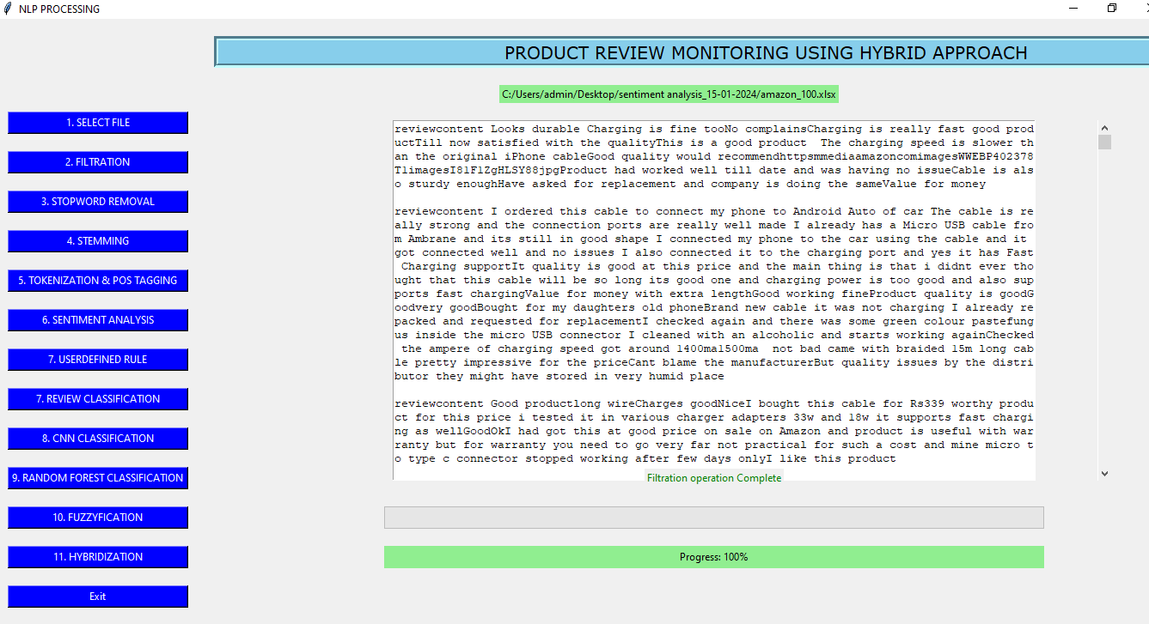
b) Integrate stop word removal to filter out common irrelevant words
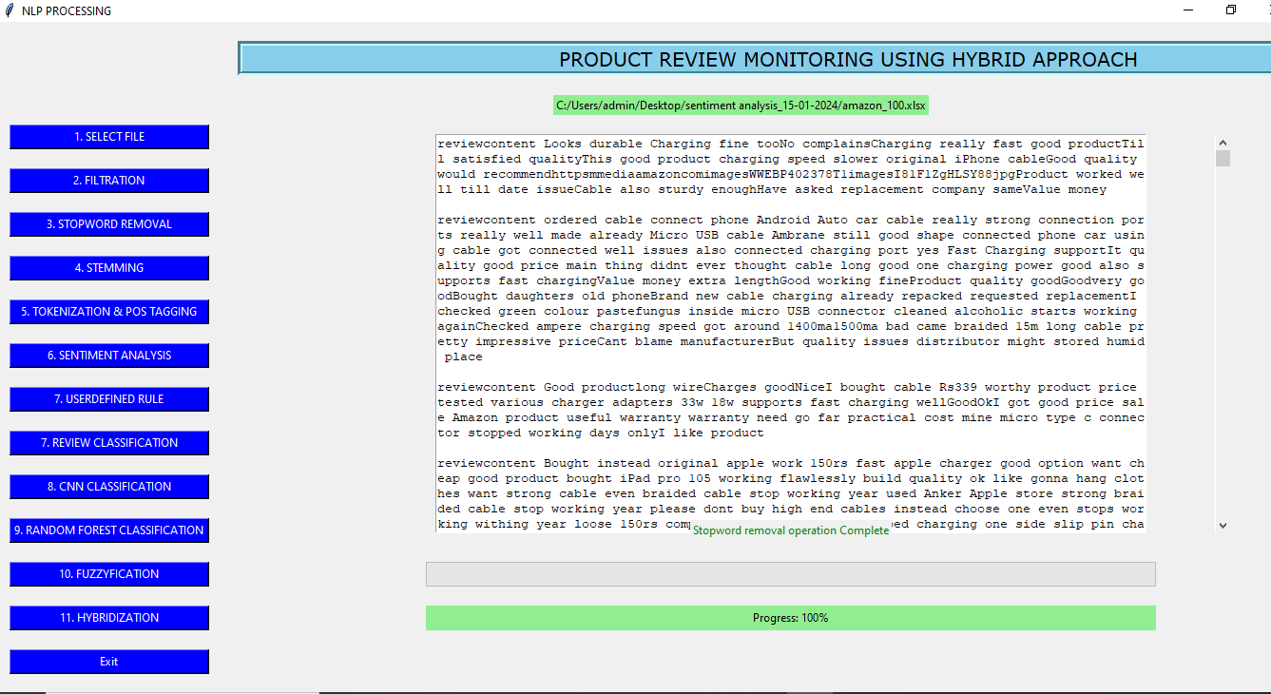

C ) Implement stemming to reduce words to their base form

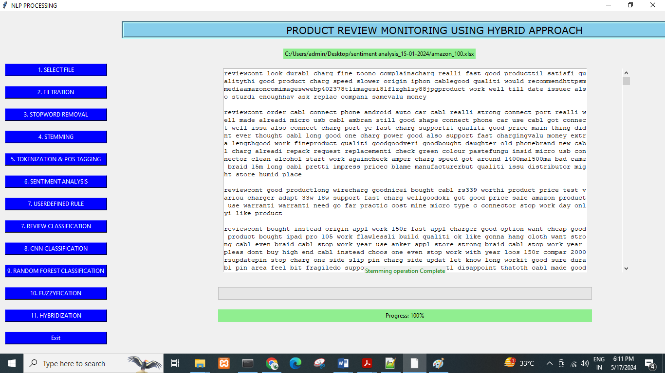

D) Implement tokenization to split the text into words or phrases

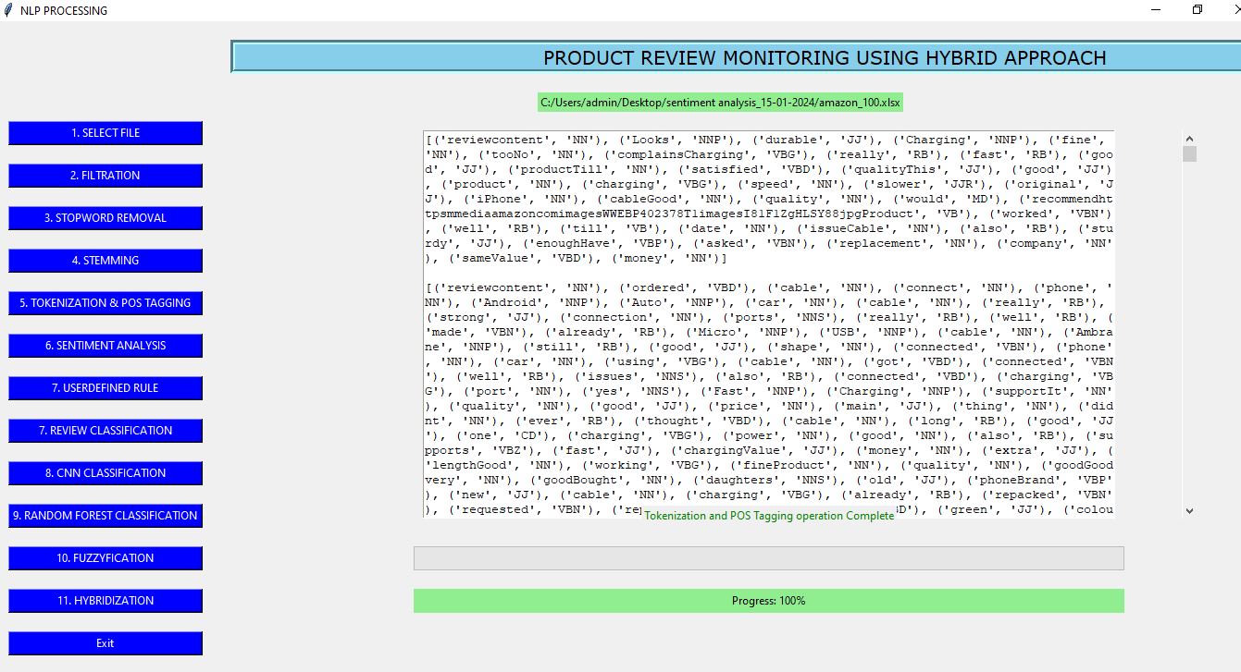

E) Sentiment Analysis:
Implement sentiment analysis using lexicon-based methods or machine learning models.
Apply the sentiment analysis technique to each pre-processed review and assign sentiment scores (positive, negative, neutral).

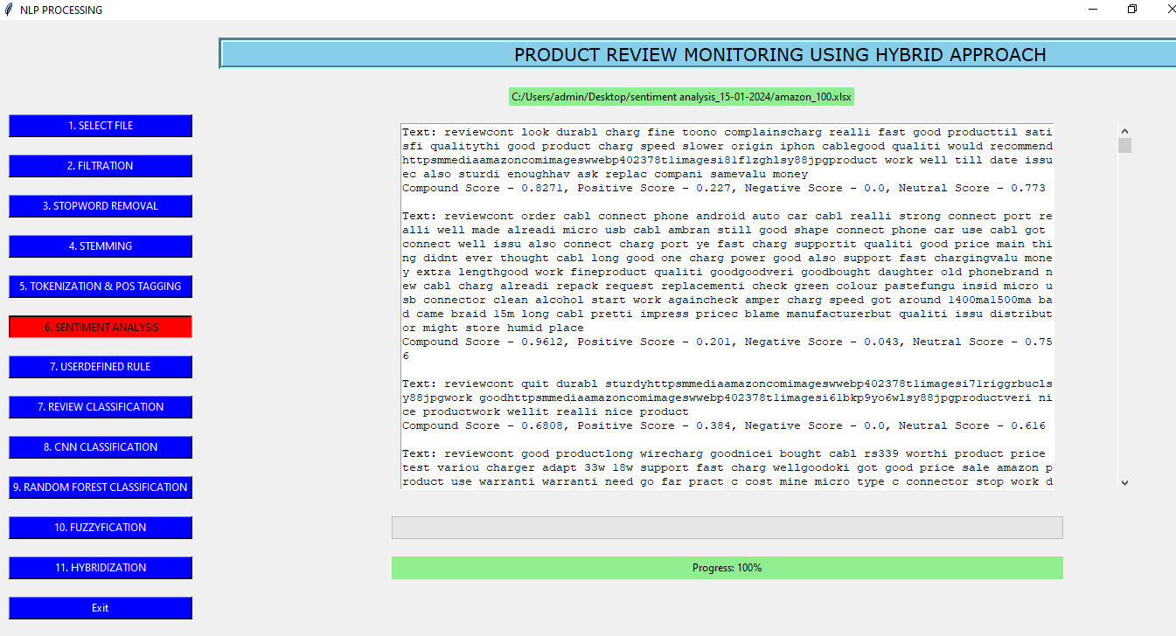

2. Implementation of User-defined rules to get text in desired format and avoid and remove unnecessary characters like emoji’s from preprocessed text as shown in figure

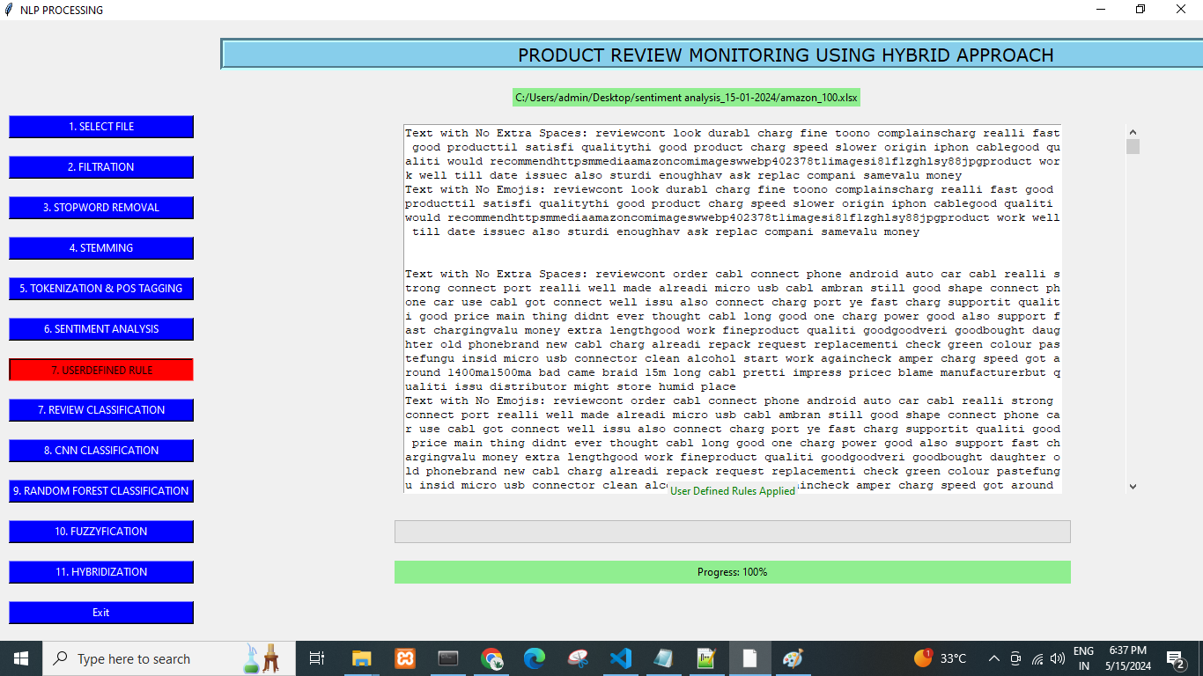

3. Implement Review classification. This algorithms learn from labeled data to classify reviews as genuine or fake based on features extracted from the text. Evaluate the performance of the model using metrics like accuracy, precision, recall, and F1-score.As shown in figure.

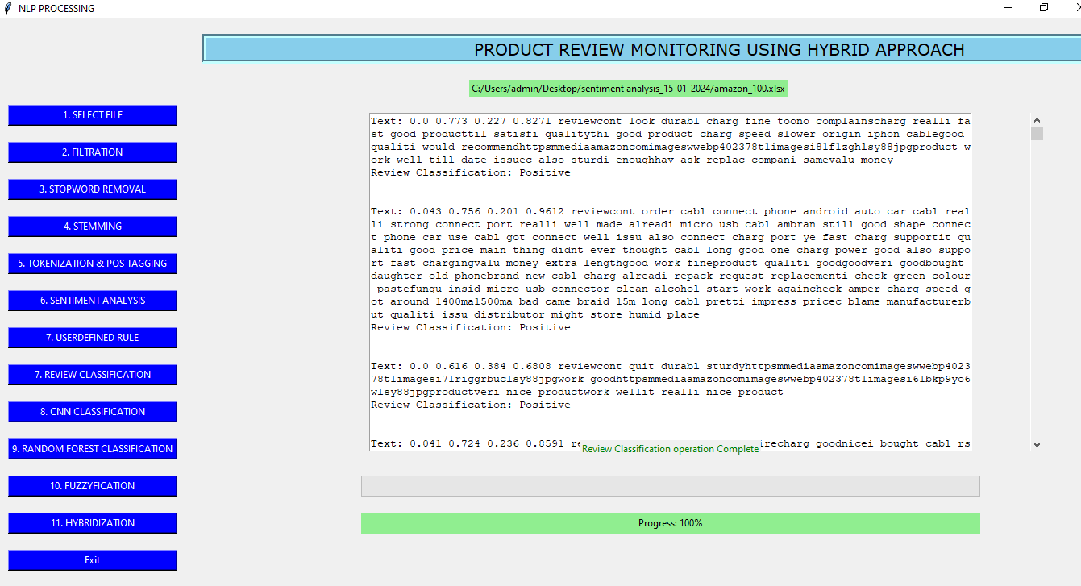

Matrix for Review classification
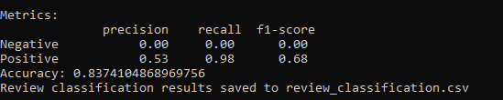

4. Implement a Convolutional Neural Network (CNN) architecture for text classification.
Prepare the pre-processed data for input to the CNN model (e.g., convert text data to numerical vectors using techniques like word embedding’s).

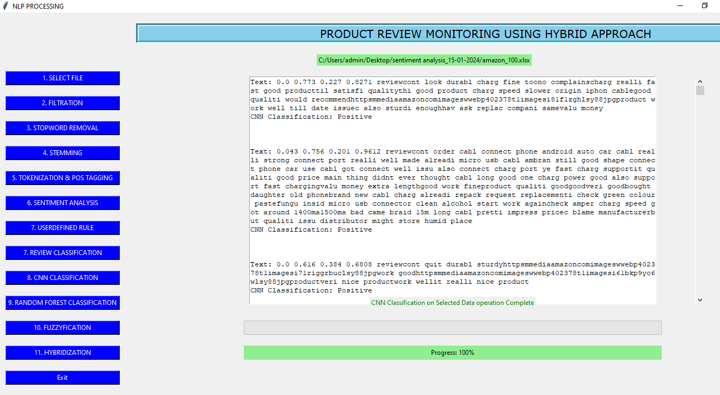

Matrix For CNN
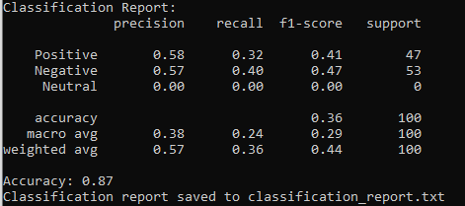

5. Implementation of Random forest model thoroughly and compare its performance with other classification algorithms to determine its effectiveness in detecting fake reviews.

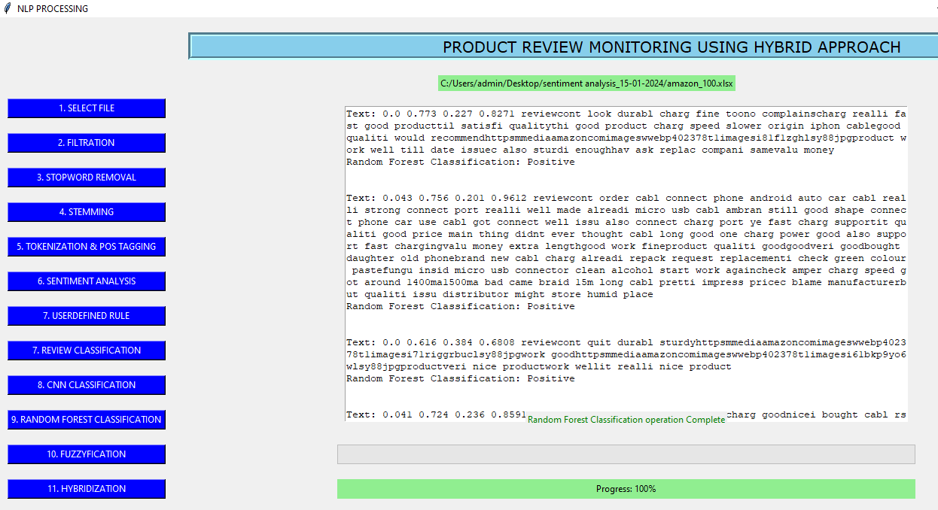

Matrix for Random forest:
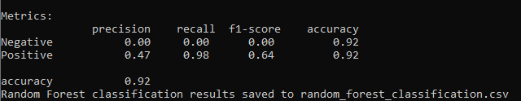

6. Implement fuzzy logic operations (e.g., fuzzy AND, fuzzy OR) to combine the inputs and generate fuzzy outputs. Fuzzification is crucial for handling uncertainty and imprecision in decision-making processes, ensuring robustness and adaptability in the system.

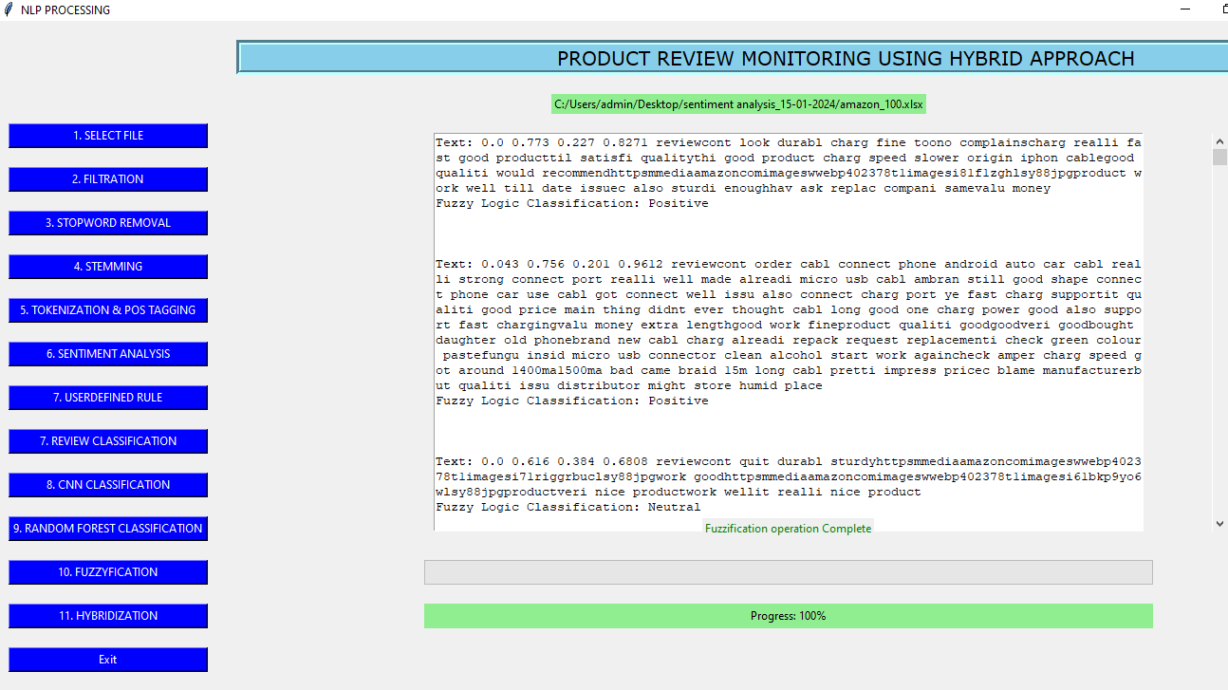

Matrix for fuzzification

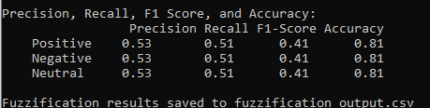

7. Implement Hybridization integrates machine learning models like random forest and Convolutional Neural Network, etc. Fine-tune the parameters of the hybrid approach based on the evaluation results to optimize performance.

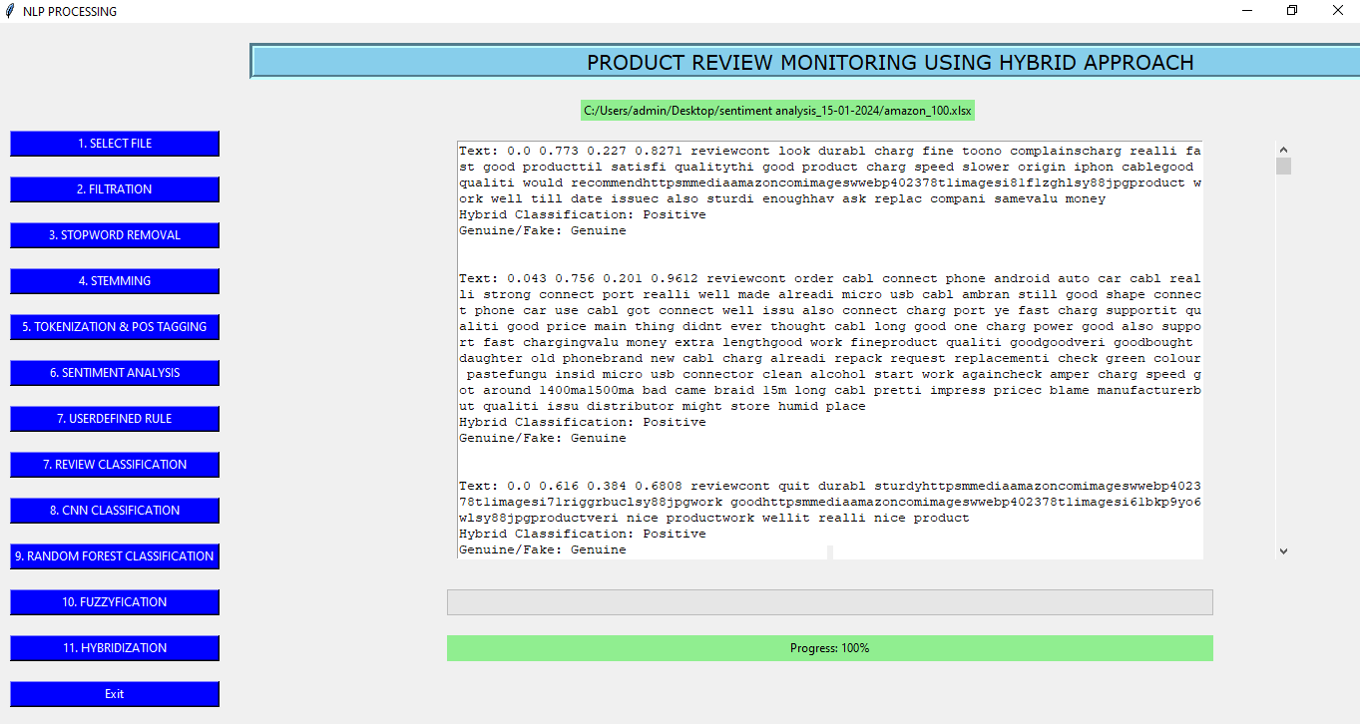

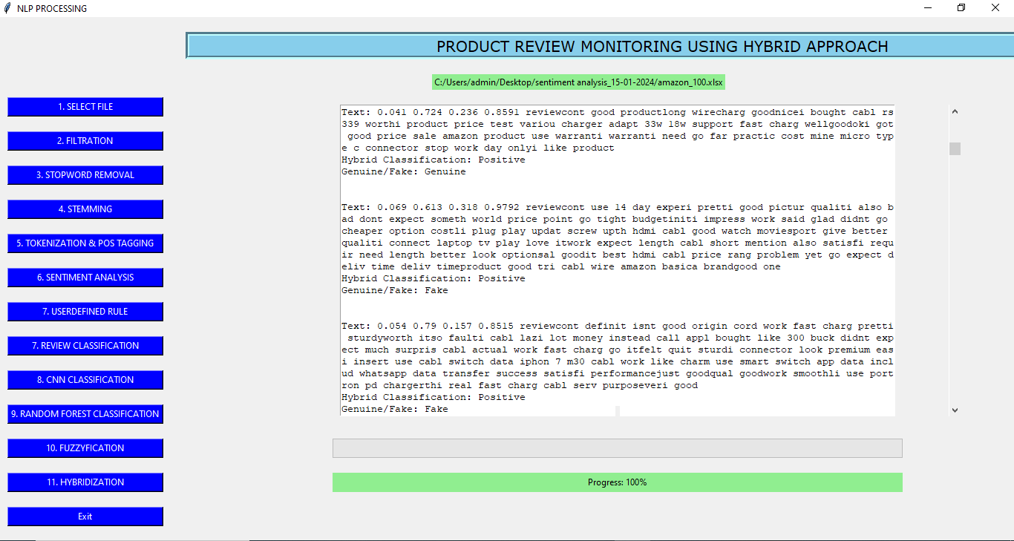

Matrix for Hybridization

